This lab is optional and should be used only if you have not been given a service principal from your Azure administrator.

You will need:

* Administration access to Azure Active Directory on your subscription/tenant

1. Navigate to Azure Active Directory and click on the “App Registrations” button:

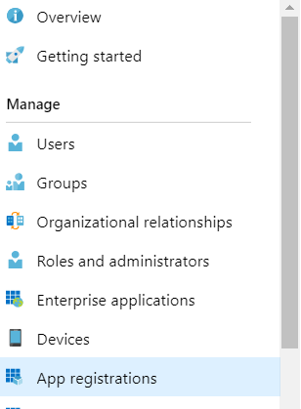

1. Click on the +New App Registration button and complete the short form, naming your service principal. It will also require you to enter a URL, but this is not used by any of the tools we will be engaging with. I have entered the ADF url to pass verification:

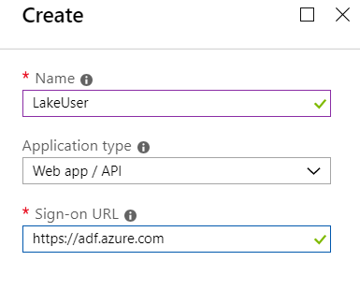

1. Click Create and you will see the details for your Service Principal:

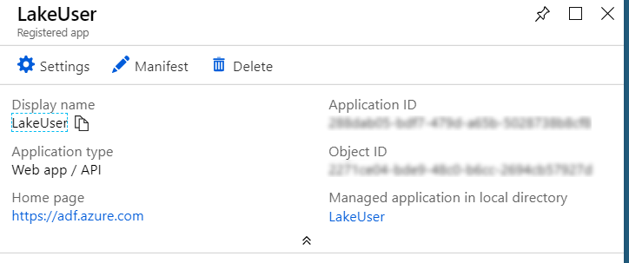

1. We now need to create a key so that we can authenticate as this user, click on the “Settings” button to open the settings blade then select “Keys”.

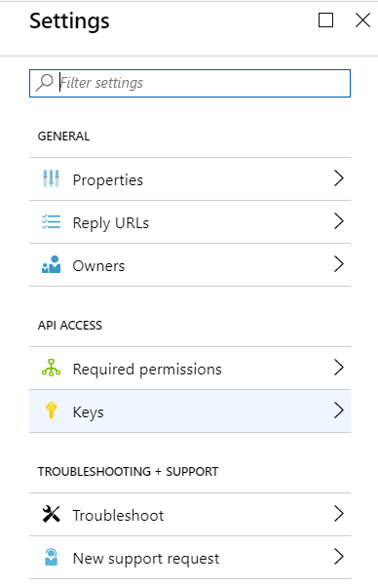

1. Add a new entry under “Passwords” for our ADF account to use:

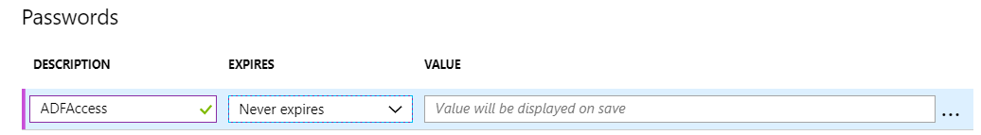

I have set the password to never expire, but you would want a more regular key cycling for any non-POC environments.

1. When you hit “Save” the key will be displayed. This key will be visible for this one time only – so make sure you take a copy now – you cannot access it ever again after this, you would need to create a new key if you lose it.

Your service principal account is now set up and ready to be used!